**Virtual Machines**

**Introduction**

In the ever-evolving landscape of computing technology, virtual machines (VMs) have emerged as a transformative solution for enhancing flexibility, scalability, and cost-efficiency in IT infrastructures. A virtual machine is a software emulation of a physical computer that runs an operating system (OS) and applications just like a physical machine. VMs are widely used in data centers, software development, testing environments, and personal computing due to their versatility and isolation capabilities.

**Definition and Core Concept**

A **Virtual Machine** is an isolated software environment that behaves like an independent computer. It runs on a physical host machine but is managed by a software layer known as a **hypervisor**. The hypervisor allocates resources such as CPU, memory, storage, and network interfaces from the physical machine to each VM, allowing multiple VMs to run simultaneously on a single physical system.

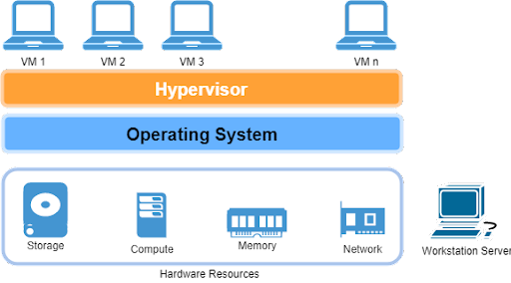

There are two main types of hypervisors:

1. **Type 1 (Bare-metal Hypervisors):** These run directly on the physical hardware. Examples include VMware ESXi, Microsoft Hyper-V, and Xen.
2. **Type 2 (Hosted Hypervisors):** These run on top of a host operating system. Examples include Oracle VirtualBox and VMware Workstation.

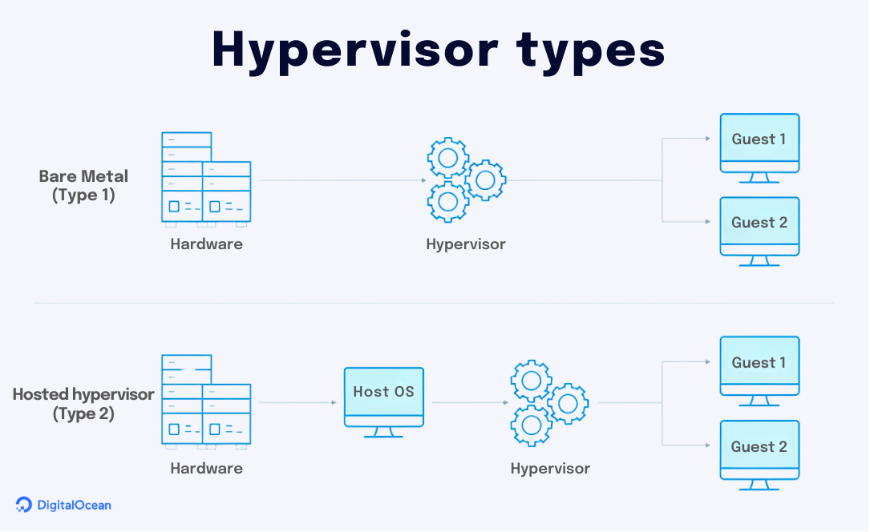

**How Virtual Machines Work**

A VM comprises several components:

* **Virtual Hardware:** Emulates physical hardware, such as a virtual CPU, RAM, hard drives, and network interfaces.
* **Guest Operating System:** Installed on the virtual hardware, it functions just like it would on a physical computer.
* **VM Image:** A file or set of files that contain the OS and configuration data.
* **Hypervisor:** Controls and manages multiple VMs, allocating physical resources dynamically.

The hypervisor ensures that VMs are sandboxed, meaning the operation of one VM does not affect others, enhancing security and system stability.

**Advantages of Virtual Machines**

1. **Resource Optimization:** Multiple VMs can share the same physical hardware, maximizing resource utilization and reducing costs.
2. **Isolation:** Each VM is isolated from others, providing a secure environment for testing and development.
3. **Scalability:** VMs can be easily created, replicated, or deleted, allowing for quick scalability.
4. **Disaster Recovery:** VMs can be backed up and restored easily, improving data recovery in case of failures.
5. **Platform Independence:** Developers can run different operating systems on the same hardware, such as Windows, Linux, and macOS.

**Use Cases of Virtual Machines**

**1. Server Consolidation**

Organizations often run multiple applications on separate servers. With VMs, these can be consolidated onto fewer physical machines, reducing hardware costs and improving efficiency.

**2. Development and Testing**

Developers can create virtual environments to test applications on different operating systems without needing multiple physical machines.

**3. Cloud Computing**

Cloud providers like AWS, Microsoft Azure, and Google Cloud use virtual machines to offer scalable computing services. Users can provision VMs in the cloud on demand.

**4. Legacy Application Support**

VMs allow older applications to run on modern hardware and operating systems by emulating their required environments.

**5. Education and Training**

VMs provide safe environments for learning and experimentation without risk to the host system.

**Challenges and Limitations**

While VMs offer numerous benefits, they are not without challenges:

* **Performance Overhead:** VMs may not perform as well as physical machines due to resource abstraction.
* **Complex Management:** Managing many VMs can become complex, especially in large-scale environments.
* **Security Risks:** Although VMs are isolated, vulnerabilities in the hypervisor could potentially allow attacks to cross VM boundaries.
* **Licensing Costs:** Running multiple OS instances may incur additional licensing costs, especially with proprietary systems.

## ****Virtual Machines vs. Containers****

In recent years, **containers** have gained popularity as a lightweight alternative to virtual machines. Containers package an application and its dependencies but share the host OS kernel, making them faster and more efficient. However, VMs offer stronger isolation and are better suited for running different OSes on the same host.

|  |  |  |
| --- | --- | --- |
| **Feature** | **Virtual Machines** | **Containers** |
| Isolation | Strong (separate OS) | Moderate (shared kernel) |
| Performance | Higher overhead | Lightweight |
| Boot Time | Minutes | Seconds |
| Use Case | Multi-OS, full isolation | Microservices, fast deployment |

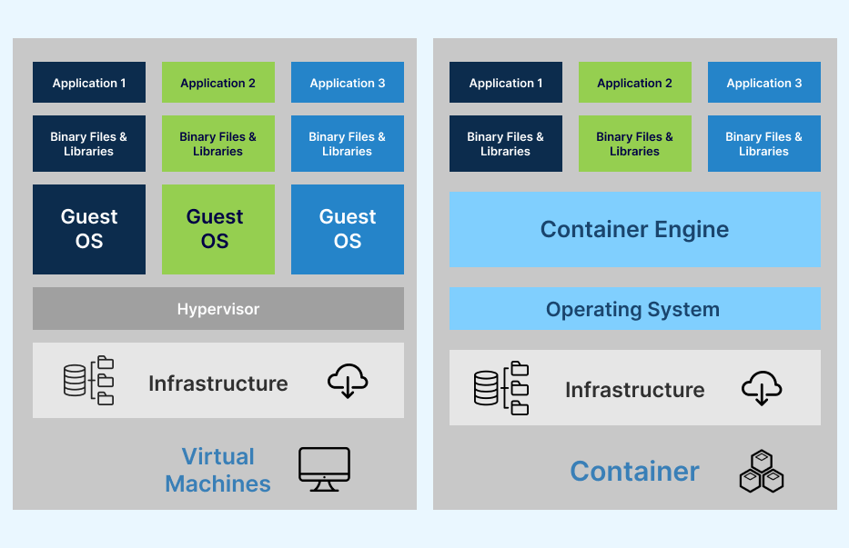

## ****Conclusion****

Virtual machines have revolutionized computing by enabling efficient, flexible, and secure utilization of physical hardware. They are a cornerstone of modern IT infrastructure, enabling better resource management, simplified system administration, and seamless development environments. As technology advances, VMs will continue to play a vital role in cloud computing, enterprise IT, and beyond.